Int n = getSize()
Начало
Random or manually?
Random
Manually
fillArrayRandom(arr, n, minValue, maxValue)
fillArray(arr, n, minValue, maxValue)
Ошибка
1
2
Wrongg
checkRange(minValue, maxValue)

Int minValue = getNumber()
Int maxValue = getNumber()
Int* arr = new int[n]
Delete[] arr
Конец
1
printArray(arr, n)
multiplyEvenPositiveByLastElement(arr, n)
findFirstOppositeGihnsPairLessThan(arr, n, x)
Int x = getNumber()
SumOfPositiveTwoDigitNumbers(arr, n)
printArray(arr, n)
2

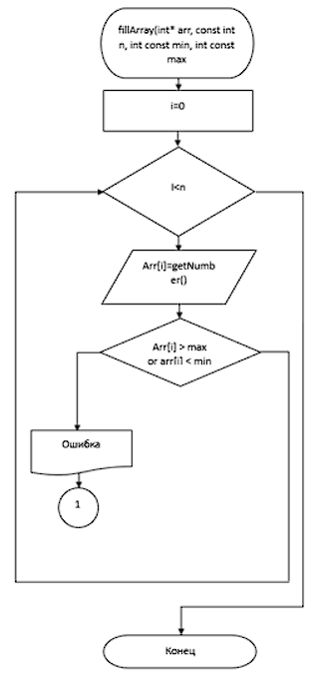
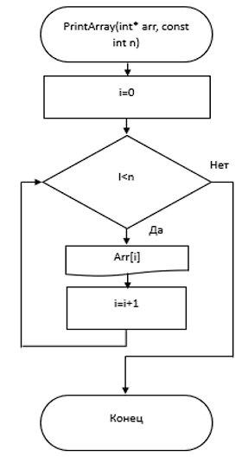
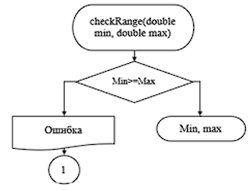
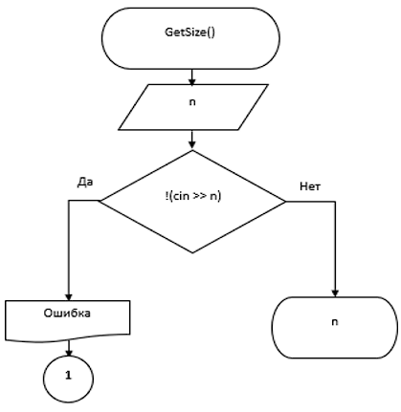
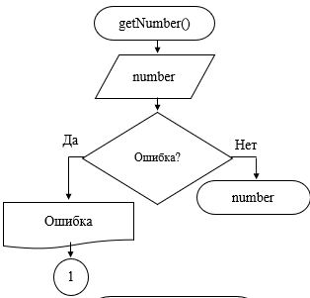
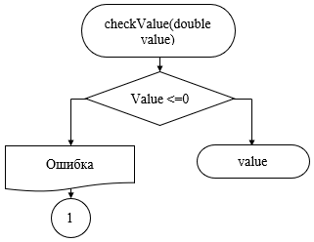
FindFirstOppositeSignsPairLessThan(int* arr, int n, int x)
s
-1
I=i+1
(Arr[i]>0 and arr[i+1]<0) or (arr[i]<0 and arr[i+1]>0
Arr[i]+arr[i+1]<x
i
I<n-1
sumOfpositiveTwoDigitNumbers(int* arr, int n)
Int sum=0, i=0

I<n

Arr[i]>=10 and arr[i] <=99
I=i+1

Sum=sum + arr[i]

Конец
I=i+1
Arr[i]=arr[i]*lastElement
Arr[i]>0 and arr[i]%2==0
I<n
lastElement = arr[n-1], i=0
multiplyEvenPositiveByLastElement(int* arr, int n)
sum

